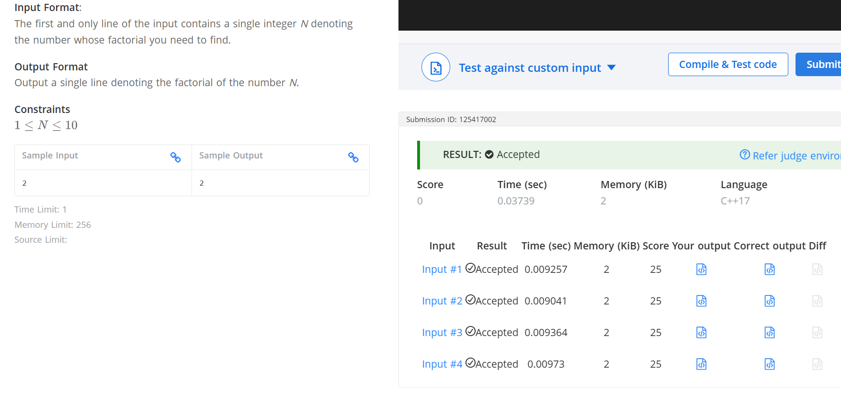

Q- Factorial
#include <iostream>
using namespace std;
int main() {
int N;
cin >> N;
int fact = 1;
for (int i=1;i<=N;i++){
fact = fact*i;
}
cout<<fact;
return 0;
}

